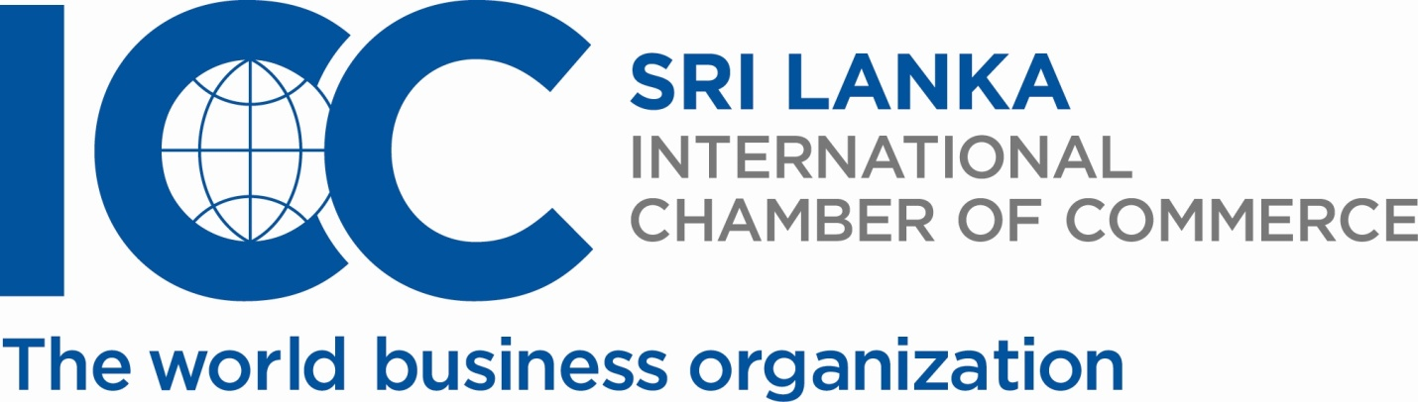
Registration Form
Workshop on Certificate of Origin
30th July 2014 at Sri Lanka Foundation
2.00 pm to 5.30 pm

Name of the participant Designation & email address
(Please include extra names in a separate sheet)

01 …………………………………………………………………………. …………………………………………………………………

02 …………………………………………………………………………. …………………………………………………………………

03 …………………………………………………………………………. …………………………………………………………………

04 …………………………………………………………………………. …………………………………………………………………

05 …………………………………………………………………………. …………………………………………………………………

Organization: …………………………………………………………………………………………………………………………………………..

Contact person: ………………………………………………………………………………………………

Address: ………………………………………………………………………………………………………………………………………………...

Tel: …………………………………… Fax: ………………………………… E mail: ………………………………………………………………

Please tick as appropriate:

Registration only – Rs. 3,570/-

Registration & ICC book- Rs. 8, 070/-

Please complete and return on or before 28th July 2014 to the International Chamber of Commerce Sri Lanka
53, Level 5, Vauxhall Lane, Colombo 00200.
Tel: 011 2307841/ 011 5230932 Fax: 011 2307841 E mail: iccsl@sltnet.lk
Investment: – Rs. 3,570/- (Includes 2% NBT)
Optional- ICC guideline book, Rs. 4,500/- nett
Cheques: In favour of “International Chamber of Commerce Sri Lanka”
Please Note: Registrations will be accepted on a first come, first served basis.

